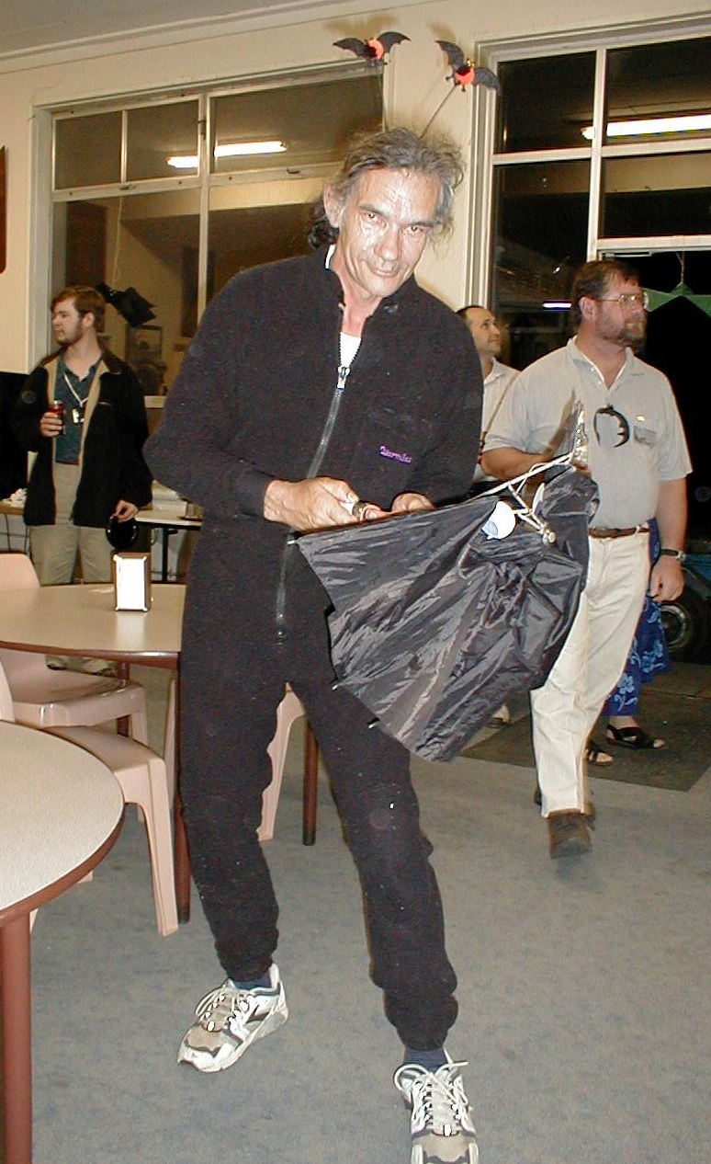
Arthur Clarke (and batswing umbrella)

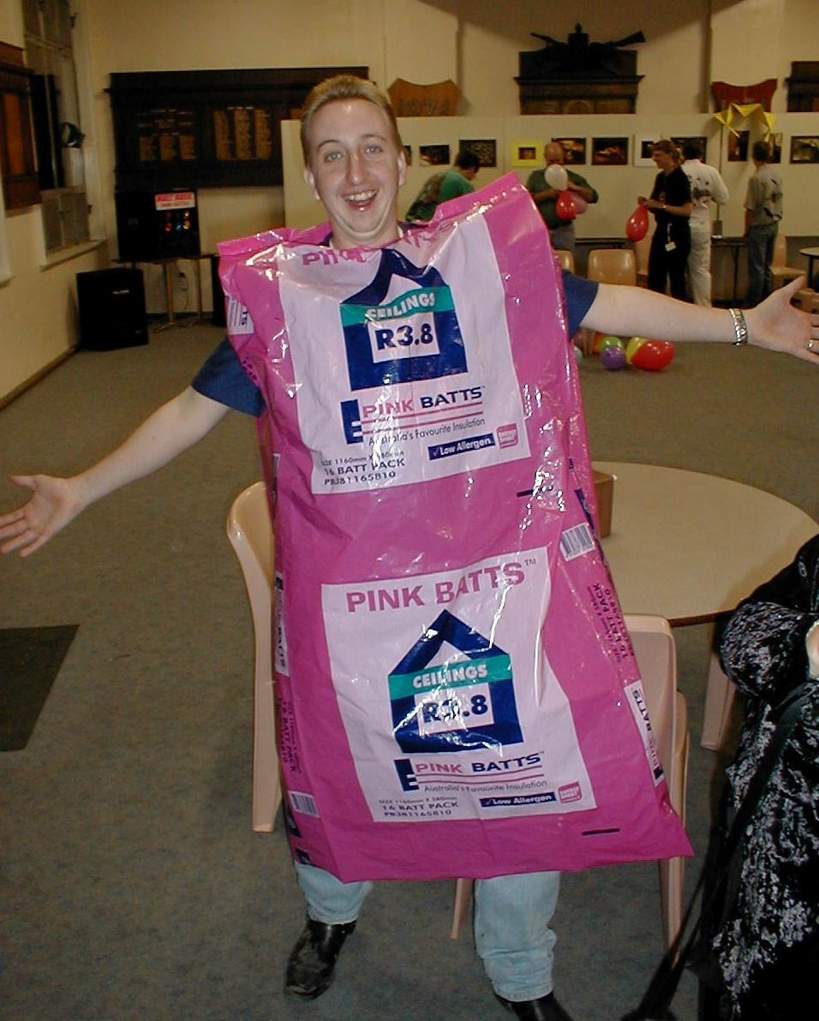
Brett Wakeman – Pink Batts!
New Years Eve Bat Party

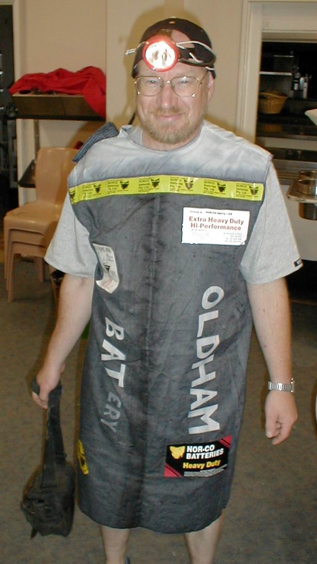
David Wools-Cobb - Battery!

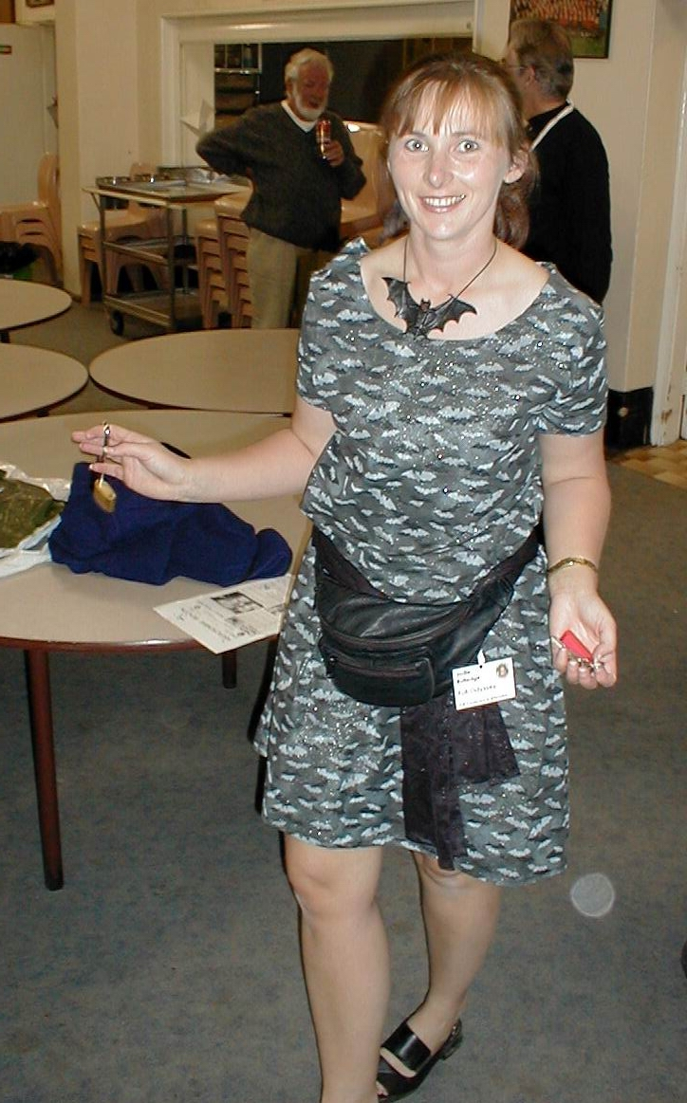
Jodie Rutledge – a bat girl

